Name Surname:Furkan Özer Date:31/10/2025
Number:2023555067 Report No:03
Digital Design Lab Report
Homework / Lab
Parts of Report:
- Description: Design a circuit for given function with VHDL codes. Simplify the circuit before design. Explain how to make compilation and simulation. Show the simulation results. Y=A’BC’+ABD’+AB’C+ABC’D’

Let’s simplify this step by step:
- Y=A′BC′+AB′C+ABC′D′+ABD′
- Y=A′BC′+A(B′C+BC′D′+BD′)
Next step,simplifying inside the paranthesis.
F=B′C+BC′D′+BD′
B | C | D | F
0 | 0 | 0 | 0
0 | 0 | 1 | 0
0 | 1 | 0 | 1
0 | 1 | 1 | 1
1 | 0 | 0 | 1
1 | 0 | 1 | 0
1 | 1 | 0 | 1
1 | 1 | 1 | 0
When B = 0 and C = 1, the output F = 1, regardless of the value of D → represented by B'C.
When B = 1 and D = 0, the output F = 1, regardless of the value of C → represented by BD'.
Therefore;
F=B′C+BD′
Result: Y=A′BC′+AB′C+ABD′

- Turth Table of Design
A(input) | B(input) | C(input) | D(input) | Y(output)
0 | 0 | 0 | 0 | 0
0 | 0 | 0 | 1 | 0
0 | 0 | 1 | 0 | 0
0 | 0 | 1 | 1 | 0
0 | 1 | 0 | 0 | 1
0 | 1 | 0 | 1 | 1
0 | 1 | 1 | 0 | 0
0 | 1 | 1 | 1 | 0
1 | 0 | 0 | 0 | 0
1 | 0 | 1 | 0 | 1
1 | 0 | 1 | 1 | 1
1 | 1 | 0 | 0 | 1
1 | 1 | 0 | 1 | 0
1 | 1 | 1 | 0 | 1
1 | 1 | 1 | 1 | 0
1 | 0 | 0 | 1 | 0

- Drawing the circuit of desired desing

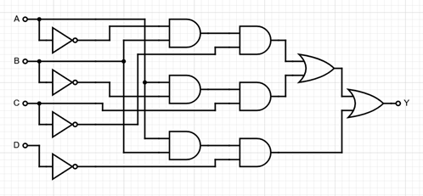

- Steps of Lab/Homework:
library IEEE;
use IEEE.std_logic_1164.all;

entity report3 is
Port (
A : in STD_LOGIC;
B : in STD_LOGIC;
C : in STD_LOGIC;
D : in STD_LOGIC;
Y : out STD_LOGIC
);
end report3;

architecture mimari of report3 is
begin

Y <= (not A and B and not C) or
(A and not B and C) or
(A and B and not D);
end mimari;

Firstly,I open the compiler and create a new source file with .vhdl extension.Then, I write my code and save it.After that,I compile the code and run the simulation.When i simulate,i add waves for the observing the results of entered values.

- Simulation Results:

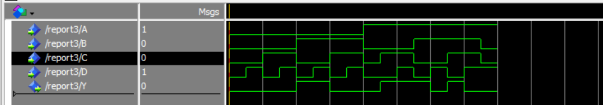

- Conclusion: After simplifying the Boolean expression Y = A’BC’ + ABD’ + AB’C + ABC’D’ to Y = A’BC’ + AB’C + ABD’, the circuit was implemented and tested using its VHDL description. The obtained truth table from the simulation exactly matches the expected theoretical truth table. Therefore, the desired circuit is correctly obtained, and the designed logic function performs as intended.

